This paper is prepared with the intention of acting as a manual for the design of a 1.74-meter diameter modular-cross parachute and a 0.7-meter ring-slot drogue parachute for the recovery of ramjet engine that will be launched by Student’s Propulsion Association Melprop (KNN Melprop) at Warsaw University of Technology.

Parachute Opening Scheme
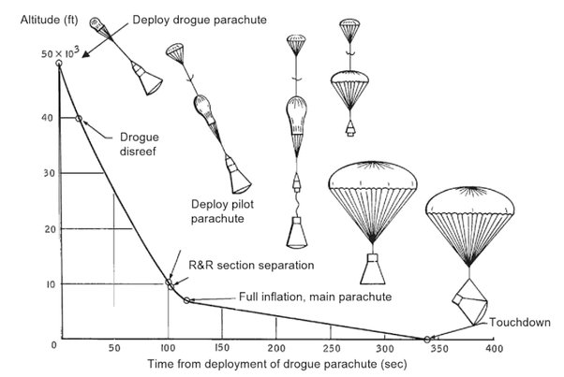
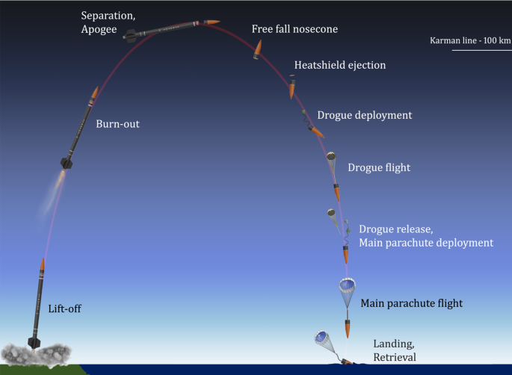
Parachute opening occurs in two stages. Deployment of the drogue chute and the deployment of main parachute. The drogue chute will open at apogee at around 12 km (expected) above sea level and will help decelerate the payload down to 40 m/s. Main Parachute will be deployed at around 600 m and the drogue will pull out the main parachute. Figures below do not represent the launch mission that will be conducted by KNN Melprop bur rather an illustration to show the opening scheme of drogue chute and main parachute.

Drogue Chute Canopy Design
For the drogue chute, a typical ring-slot parachute design with 0.7 meter nominal diameter will be satisfactory. An existing parachute with the same diameter, providing similar performance can also be proposed by the manufacturer.

Parachute Specifications of Main Canopy
Main canopy will be constructed as a modular-cross canopy for short opening time, light weight and small packing volume. The material of the canopy will be nylon (25 g/m^2 or less) whilst the suspension lines will be made of Kevlar The required specifications to achieve the mission requirements for landing are as follows:
Mass of Payload: 50kg
Deployment Altitude: 1000m
Deployment Velocity: 40 m/s
Effective Drag Area ${\left(C_{D}S\right)}_{O}$: 9.7258 m² $≈$ 9.8 m²
Nominal Diameter D_{O} Side Length : 3.2124 m 3 m
Required Terminal Velocity/Landing Velocity: 10 m/s
Opening Force Magnitude: 636.7225 N
Suspension Line Length: 5 m
Number of Suspension Lines: 24
Rated Ultimate Strength of Suspension Line: 27 N
The key requirements are small packing volume, hence small nominal diameter with no significant change in effective drag area. An existing parachute with the same diameter, providing similar performance at similar altitude and velocities can also be proposed by the manufacturer.

Main Canopy Design
This section discusses the structural design of a modular-cross canopy. Modular design canopy is basically 2 cross parachutes overlapping. Below you can see graphical illustrations for a cross canopy and a modular cross canopy.
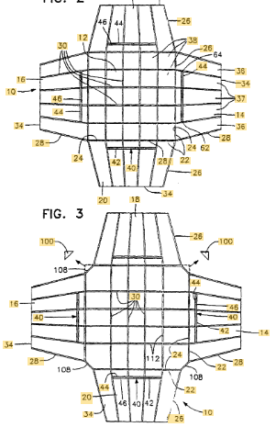
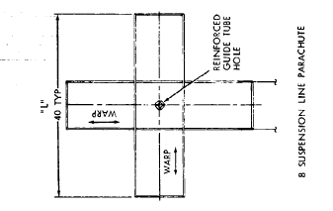
24 SUSPENSION LINE PARACHUTE
Image for visualization purposes

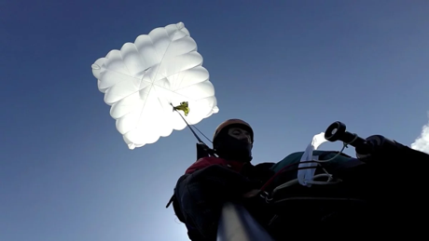

MATLAB CODES AND WORKSTATION CAN BE FOUND BELOW
